Questions:

* Is jan deliverable progress report part of final hand in? or just a progress report?
* Imagine lit review is part of the progress report? Or is it separate?

Plan:

Mental health bot

Challenges:

* Ask non harmful questions – non advisory techniques
* Machine learning will

System:

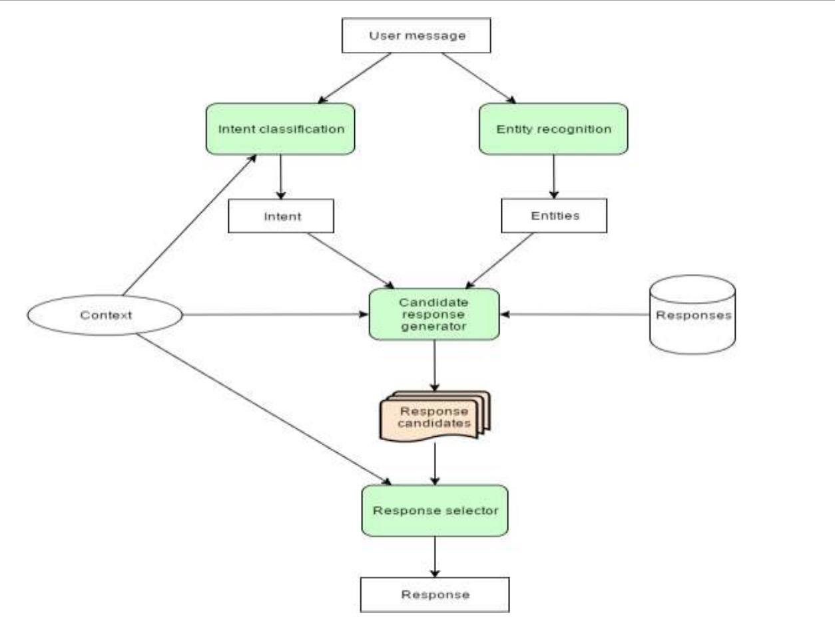

Overcoming mental health emergencies:

* Remind user the bot isn’t a replacement for a human and if there was an emergency give advice on who to talk to

[cognitive behavioral therapy (CBT)](https://www.healthline.com/health/behavioral-therapy) — an evidence-based approach to treatment.

Relevant bots: Endurance dementia bot, insomnibot

Methodology: this is what im using as tools

* What I’m implementing
* The results I predict

Roughly 1/3 of project done

New plan:

Step 1: write command line program that takes question and output’s the same question

Step 2: